DFD of Project Artify

Group: BX-03

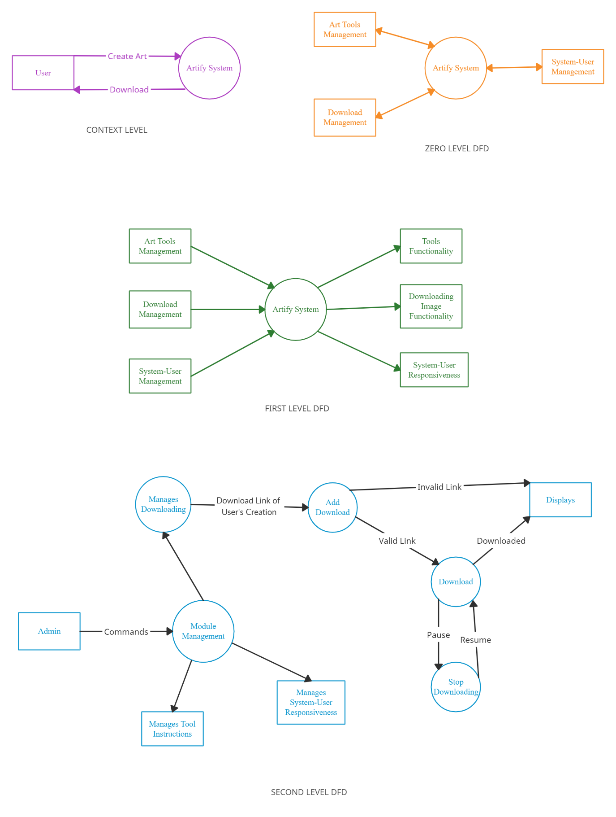

ERD of Project Artify

Group: BX-03

We don't have application of dbms system in our webapp. And have no need to save logs of the user. Hence, erd is not needed.